The Worship of God
February 3, 2019

F
or as the heavens are high above the earth,
so great is your steadfast love for those who fear you.

As far as the east is from the west,
so far have you removed our transgressions from us.

—Psalm 103.11-12

Gathering At God’s Invitation

Music for Gathering Marietta Mobley piano

Lighting the Christ Candle Harrison Rose

Opening Sentences Rev. Alan Sherouse

Ministry of Music Steve Potts

Praise, My Soul, the King of Heaven

Instrumental Ensemble, Keith Burroughs director

†Responsive Psalm 103 Terri Vancil

Bless the Lord, O my soul,

and all that is within me, bless God’s holy name.

Bless the Lord, O my soul,

and forget not all God’s benefits—

who forgives all your sins

and heals all your diseases;

who redeems your life from the grave
and crowns you with steadfast love and mercy;

who satisfies your desires with good things
so that your youth is renewed like an eagle’s.

O Lord, you provide vindication and justice
for all who are oppressed. You made known your ways to Moses
and your works to the children of Israel.

Lord, you are full of compassion and mercy,
slow to anger and abounding in steadfast love;

you will not always accuse us,
nor will you keep your anger forever.

You have not dealt with us according to our sins,
nor repaid us according to our iniquities.

For as the heavens are high above the earth,
so great is your steadfast love for those who fear you.

As far as the east is from the west,
so far have you removed our transgressions from us.

As a father has compassion for his children,
so you have compassion for those who fear you, O Lord.

Bless the Lord, all you works of God,
in all places where God rules; bless the Lord, O my soul.

Psalm 103.1-13, 22 (Evangelical Lutheran Worship)

†Hymn of Praise 25 Andrews
Praise, My Soul, the King of Heaven

†Words of Friendship Rev. Amy Grizzle Kane

A Time for Children Christina McCord

Musical Interlude

During the Musical Interlude, children, ages four through first grade,
may attend Junior Church and return to the sanctuary after the sermon.

Prayers of God’s People Rev. Sherouse

The Lord’s Prayer Albert Hay Malotte
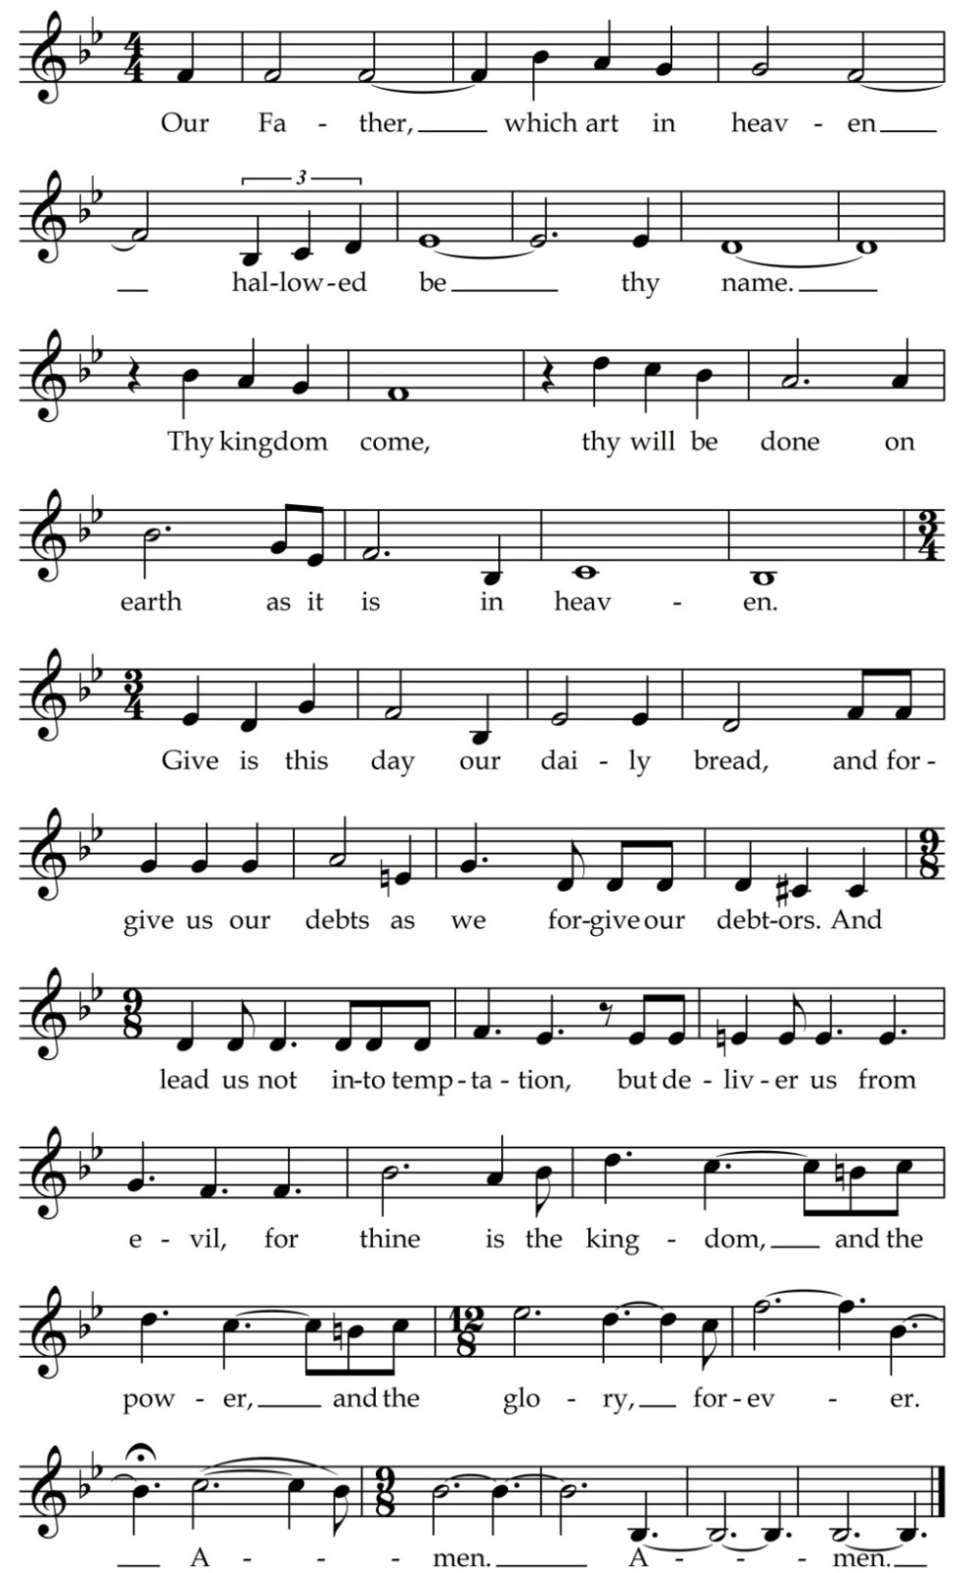

Text: Matthew 6.91-13 KJV; Music: Albert Hay Malotte, 1935
Opening of God’s Word William Bolton

Hearing God’s Word

Scripture Lesson Rev. Sherouse
Matthew 28.19-20, II Corinthians 13.11-13

Sermon Dr. Molly Marshall
The Church as Icon of the Trinity

Responding to God’s Word

†Hymn of Response 782 Divernon
Come, Share the Lord

The Lord’s Supper Rev. Kane
David Worsley deacon chair

Offertory Prayer Brad Wall, deacon

Offertory Hymn Dennis

A parting hymn we sing around your table, Lord;
again our grateful tribute bring, our solemn vows record.

Now we have seen your face, and felt your presence here;
So may the savor of your grace in word and life appear.

The purchase of your blood, by sin no longer led,
the path our dear Redeemer trod may we rejoicing tread.

In self-forgetting love be our communion shown,
until we join the Church above, and know as we are known.

Amen. —Aaron R. Wolfe, 1821-1902

Sending Into God’s World

†Benediction Dr. Marshall

