The Worship of God
The Transfiguration of Our Lord
March 3, 2019

W
here the Spirit of the Lord is there is freedom. And all of us, with unveiled faces, seeing the glory of the Lord as though reflected in a mirror, are being transformed into the same image from one degree of glory to another; for this comes from the Lord, the Spirit. Therefore, since it is by God’s mercy that we are engaged in this ministry, we do not lose heart.

—II Corinthians 3.17—4.2

Gathering At God’s Invitation

Music for Gathering Marietta Mobley piano

Lighting the Christ Candle Danielle Delgado

Opening Sentences Rev. Alan Sherouse

Ministry of Music Martha Lynn Thompson

Improvisation on Cwm Rhondda

Adult Handbell Choir

Tony Sanders, Music Intern directing

†Responsive Psalm 99 Baker Lawrimore

The Lord is king;
let the people tremble.

The Lord is enthroned upon the cherubim;
let the earth shake.

The Lord, great in Zion, is high above all peoples.
Let them confess God’s name, which is great and awesome;

God is the Holy One.

O mighty king, lover of justice, you have established equity;
you have executed justice and righteousness in Jacob.

Proclaim the greatness of the Lord and fall down
before God’s footstool;
God is the Holy One.

Moses and Aaron among your priests,
and Samuel among those who call upon your name, O Lord;
they called upon you, and you answered them,

you spoke to them out of the pillar of cloud;
they kept your testimonies and the decree that you gave them.
O Lord our God, you answered them indeed;

you were a God who forgave them,
yet punished them for their evil deeds.
Proclaim the greatness of the Lord and worship upon God’s holy hill;
for the Lord our God is the Holy One.

—Psalm 99

†Hymn of Praise Cwm Rhondda
See Our Lord in All His Glory
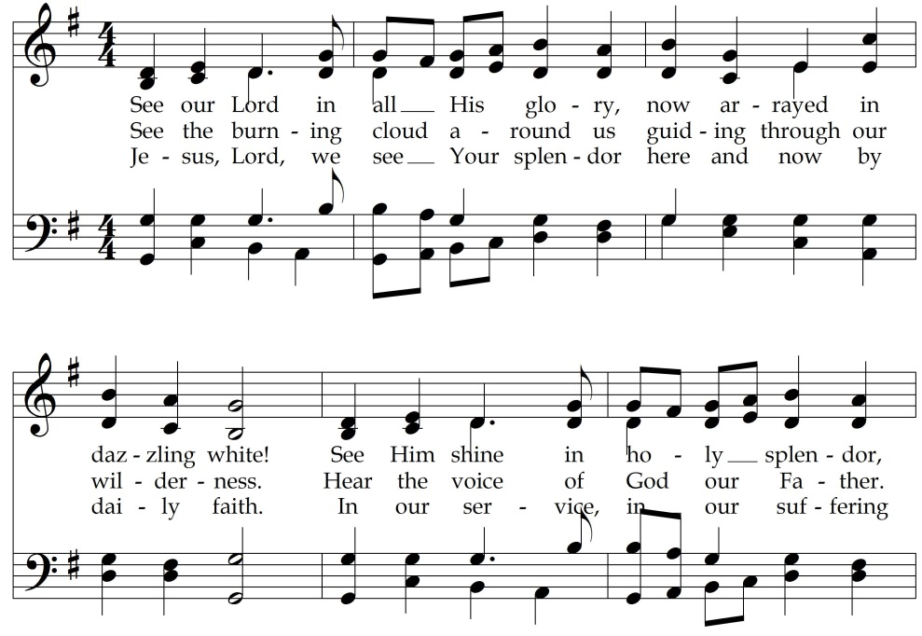

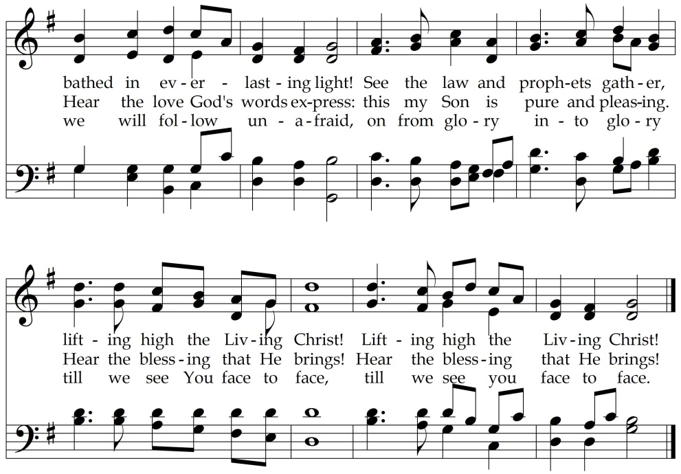

Words: Ken Bible, 2004, Music: John Hughes, 1907
Words © LNWhynms.com (admin. by The Copyright Company).
Used by permission under OneLicense.net #A-707453.

†Words of Friendship Rev. Courtney Willis

A Time for Children Christina McCord

Musical Interlude

During the Musical Interlude, children, ages four through first grade,
may attend Junior Church and return to the sanctuary after the sermon.

Prayers of God’s People Rev. Darnysha Nard

The Lord’s Prayer Albert Hay Malotte

(The congregation is invited to sing The Lord’s Prayer found on
page 632 in the hymnal.)

Opening of God’s Word Aubreigh Duckworth

Hearing God’s Word

Scripture Lesson Luke 9:28-43a Rev. Willis

Sermon Rev. Alan Sherouse
The View From the Mountain

Responding to God’s Word

†Hymn of Response 90 Christi Sanctorum
Christ Is the World’s Light

Musical Interlude

The Lord’s Supper Rev. Nard
David Worsley deacon chair

Music for Communion Arnold B. Sherman
Grazioso
Adult Handbell Choir

Offertory Prayer David Angel, deacon

Choral Offering Douglas Wagner

We Will Praise You
Young Musicians, Sally Alexander accompanist
Baker Lawrimore, Ministry Fellow directing

We will praise You, Lord and Father, maker, giver,
and adore with joy for everlasting.
We will sing and be glad in You.

Sending Into God’s World

†Benediction Rev. Sherouse

†Organ Postlude Paul Manz
Cwm Rhondda
Tony Sanders, Music Intern organ

