The Worship of God
Third Sunday of Advent—Joy
December 16, 2018

R
ejoice in the Lord always; again I will say, Rejoice.
Let your gentleness be known to everyone. The Lord is near!
Do not worry about anything, but in everything by prayer
and supplication with thanksgiving let your requests be made known to God. And the peace of God, which surpasses all understanding,
will guard your hearts and your minds in Christ Jesus.

—Philippians 4.4-7

Gathering At God’s Invitation

Opening Sentences Rev. Alan Sherouse

†Processional Song
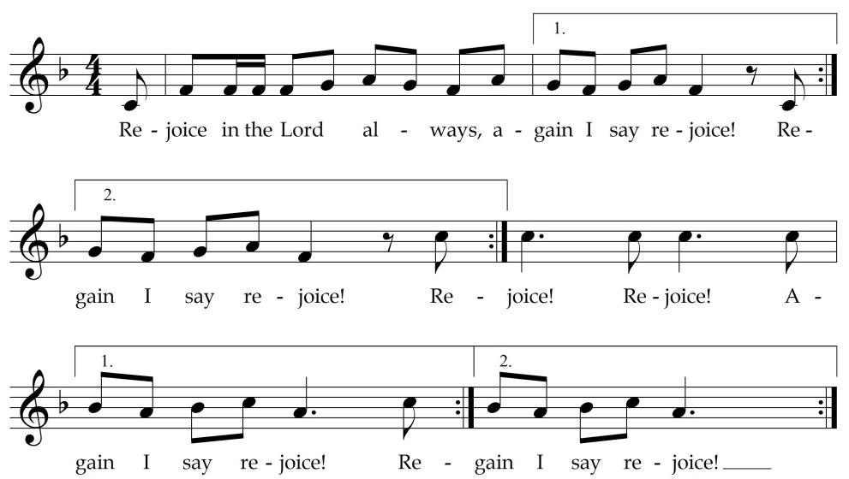

Advent Wreath Seth, Genelle, Caleb and Madilyn Hix

God is indeed my salvation;
I will trust and won’t be afraid.

The Lord is my strength and my shield;
God has become my salvation.

You will draw water with joy from the springs of salvation.
And you will say on that day:

Thank the Lord; call on God’s name;
proclaim God’s deeds among the peoples;
declare that God’s name is exalted.

Sing to the Lord,
who has done glorious things;
proclaim this throughout all the earth.

Shout and sing for joy, city of Zion,
because the holy one of Israel is great among you.

–Isaiah 12.2-6 from The Common English Bible

Ministry of Music
Welcome, Holy Child Carol Dickerson
Sing With the Angels Johnny Carr
Preschool Choir
Louise Burroughs teacher, Meganne Gould, Fia Goudes assistants

He Is Born/Sing Noel Vicki Hancock Wright
Music Makers
Penny Rowe director, Rosemary Kellam accompanist
Renee Fila assistant, Jim Bearden percussion

Jesus Is Born, Prince of Peace Lloyd Larson
Young Musicians
Terri Vancil director, Sally Alexander accompanist, Lauren Shriver cello
Keeley Duckworth, Jack Foxworth assistants

Congregational Response

Silent night! holy night! Son of God, love’s pure light,
radiant beams from thy holy face,
with the dawn of redeeming grace,
Jesus, Lord at thy birth, Jesus, Lord at thy birth.
A Time for Children Christina McCord

†Passing of the Peace

Musical Interlude

During the Musical Interlude, children, ages four through first grade,
may attend Junior Church and return to the sanctuary after the sermon.

Words of Friendship Dr. Steve Sumerel

†Carol 133 Veni Emmanuel
O Come, O Come, Emmanuel
Lauren Shriver cello

Prayers of God’s People Indigo Stephens

Choral Anthem Kay Hawkes Goodyear
O Little Town of Bethlehem
Adult Ensemble and Young Musicians
Tony Sanders accompanist

Hearing God’s Word

Scripture Lesson Luke 3.7-18 Ada Noel Harris
Morgan Alexander

Sermon Rev. Sherouse
Prepare Him Room

Responding to God’s Word

†Hymn of Response 166 Jungst
While by the Sheep We Watched

Musical Interlude

Missions Moment

Cooperative Baptist Fellowship Offering for Global Missions

Offertory Prayer Andrew Petitt

Choral Offering Noel Regney/Gloria Shayn
Do You Hear What I Hear
Adult Ensemble

Sending Into God’s World

†Benediction Rev. Sherouse

†Congregational Response Antioch

Joy to the earth! the Savior reigns;
let all their songs employ;
while fields and floods, rocks, hills, and plains
repeat the sounding joy, repeat the sounding joy,
repeat, repeat the sounding joy.

Guests are warmly welcomed today. There are several ways during the worship hour that we can become better acquainted.

During the Words of Friendship, we will share a personal greeting with those sitting around us. You will find a Connection Card in the bulletin that can be filled out and dropped in the offering plate as it is passed in the service. Ministers will be greeting worshipers at each exit door after the service.

