The Worship of God
Second Sunday of Easter
April 8, 2018

Music for Gathering Marietta Mobley, piano

Christ Candle Carter Bland

Opening Sentences Rev. Alan Sherouse

†Responsive Call to Worship Terri Vancil

Alleluia! Christ is risen.

He is risen indeed. Alleluia!

Praise the God and Father of our Lord Jesus Christ.

God has given us new life and hope.

God has raised Jesus from the dead.

God has claimed us as his own.

God has brought us out of darkness,

and has made us light to the world.

Alleluia! Christ is risen.

He is risen indeed. Alleluia!

†Hymn of Praise 247 Lancashire
The Day of Resurrection

†Words of Friendship Christina McCord

As we greet one another children may gather with Christina on the platform steps.

A Time for Children Christina McCord

After the children’s message, children, ages four through first grade may attend Junior Church and return to the sanctuary after the sermon.

Congregational Verse Ancient Words
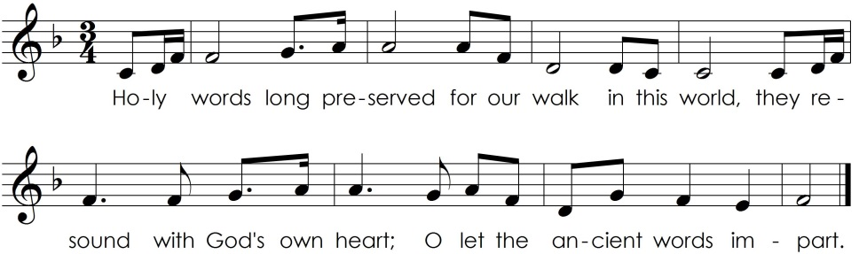

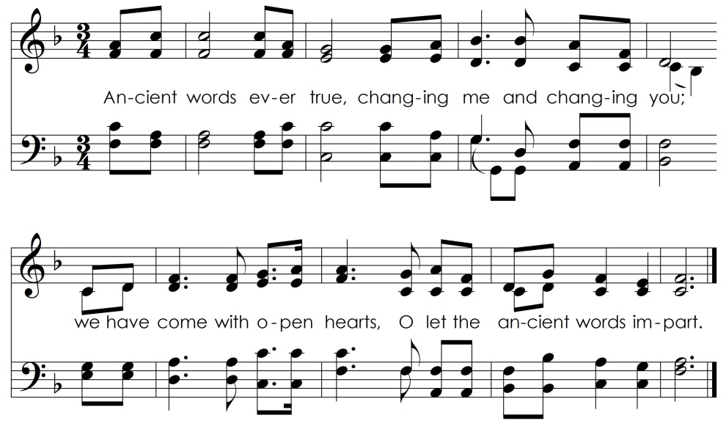

Words and Music: Lynn DeShazo, © 2001 Integrity’s Hosanna! Music.
All Rights Reserved. Reprinted under One License #A-707453.

Opening of God’s Word Patrick Whitehead

Prayers of God’s People Sarah Parker

Scripture Lesson Rev. Chris Cherry
John 20:19-31

Sermon Rev. Sherouse
For Those Who Missed the Miracle

†Hymn 254 Ode to Joy
Alleluia, Alleluia! Hearts to Heaven

Musical Interlude

The Lord’s Supper

Communion Hymn 240 Alleluia No. 1
Alleluia, Alleluia! Give Thanks

Offertory Prayer David Angel, deacon

Musical Offering Jeff Cranfill
Jesus Keep Me Near the Cross
Instrumental Ensemble, Keith Burroughs director

†Benediction Rev. Sherouse

Sanctuary flowers are given to the glory of God
in memory of Cecil and Edna Williams
by Archie Williams

Guests are warmly welcomed today. There are several ways during the worship hour that we can become better acquainted. During the Words of Friendship we will share a personal greeting with those sitting around us. You will find a Connection Card in the bulletin that can be filled out and dropped in the offering plate as it is passed in the service. Ministers will also be greeting worshipers at each exit door after the service.

